**ASSIGNMENT-1 by Aditya Singh 2K19/EP/005**

% 1. Define a row vector and column vector

a = [5, 9, 18];

b = [3; 8; 2];

% (i) Addition of both the vectors.

add = a+b

% (ii) Subtraction of both the vectors

sub = a-b

% (iii) Multiplication of both the vectors

mult = a*b

% (iv) Division of both the vectors

div = a./b

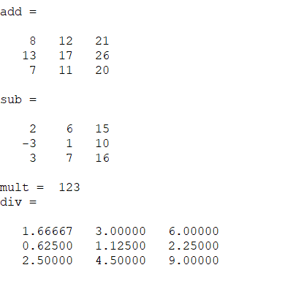

% (v) Find the size of both the vectors

aSize = size(a)

bSize = size(b)

% (vi) Reference any element of both the vectors

aRef = a(2)

bRef = b(1)

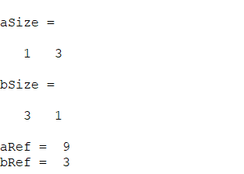

% 2. For a vector x, write down the Matlab/octave command

x = [1 : 0.3 : 4];

% (i) cos x^2 - sin x^2

m = cos(x.^2);

n = sin(x.^2);

C = m-n

% (ii) e^x(1 + cos 3x)

D = exp(x).*(1 + cos(3*x))

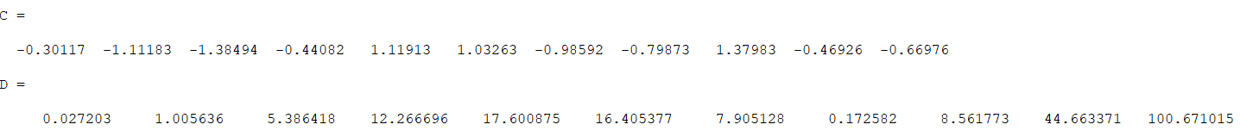

% 3. Let u be the row vector defined as [1 2 3 4 5] then write the following commands

u = [1 2 3 4 5];

% (i) Subtract 1 from each element

E = u-1

% (ii) Add 10 to the even-index elements

F = u;

F(2:2:end) = F(2:2:end) + 10

% (iii) Compute the square root of each element

G = sqrt(u)

% (iv) Raise to the power 2 each element

H = u.^2

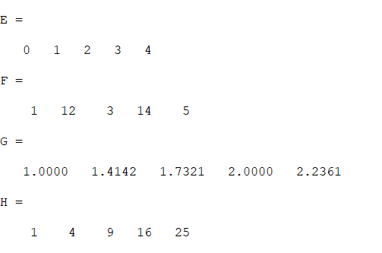

% 4. Consider two complex numbers as

c1 = -2 + 4*i;

c2 = 6 - 9*i;

% operations on complex numbers

cadd = c1+c2

csub = c1-c2

cmul = c1*c2

cdiv = c1/c2

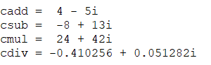

% 5. Plot the following functions using the linearly spaced vector

x = linspace(0,4*pi);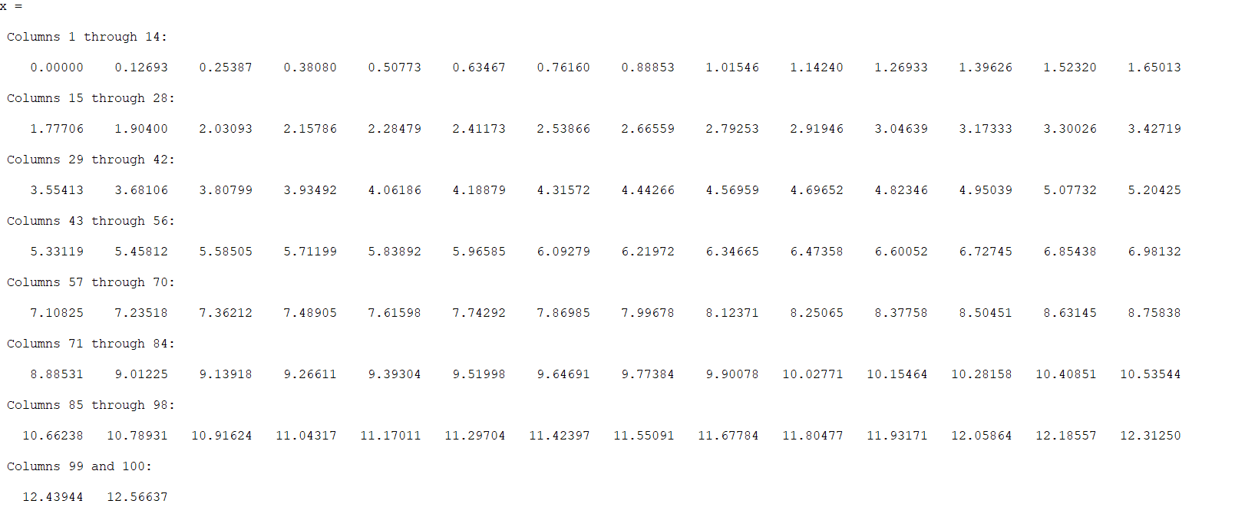

y = linspace(0,10); %for e^x

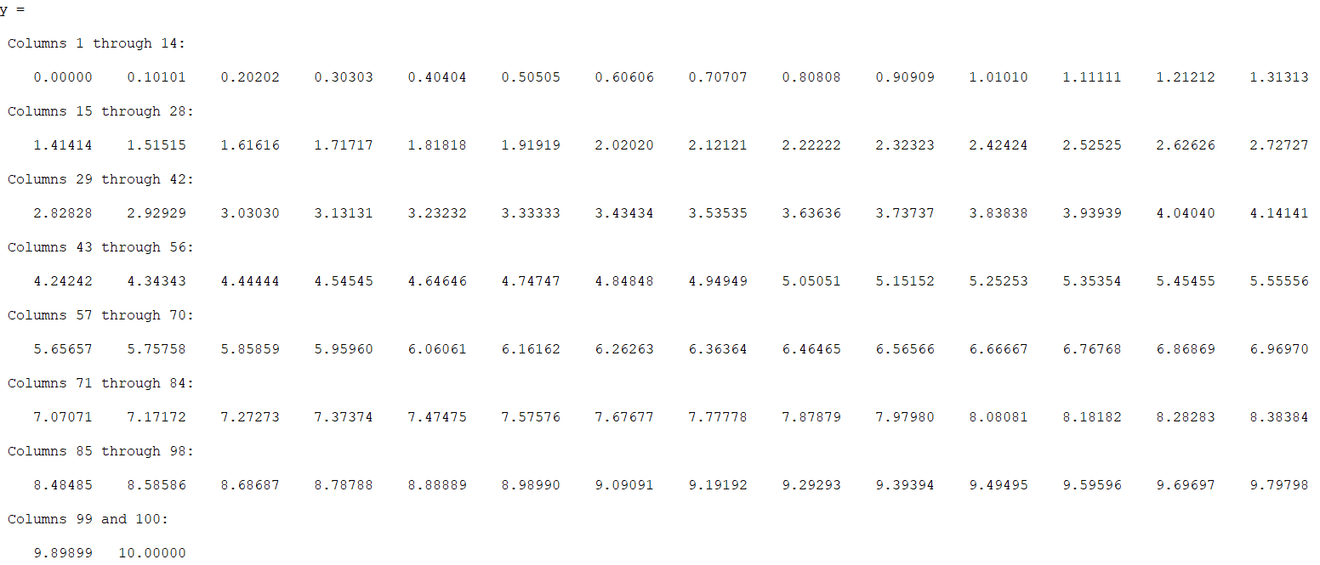

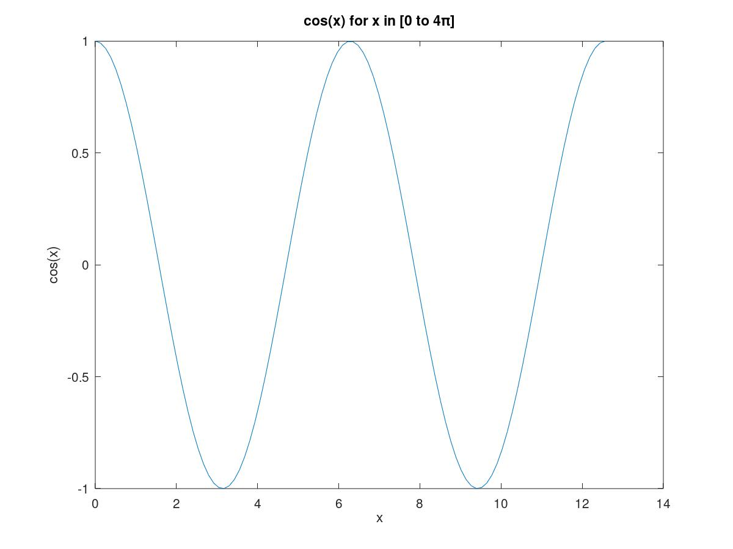

% (i) cosx

plot(x,cos(x))

title ("cos(x) for x in [0 to 4π]");

xlabel ("x");

ylabel ("cos(x)");

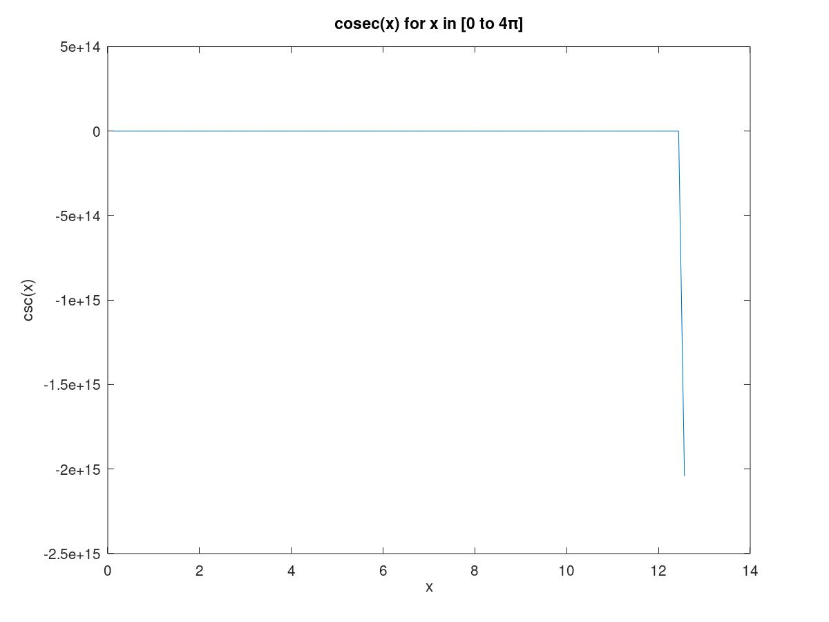

% (ii) cosec x

plot(x,csc(x))

title ("cosec(x) for x in [0 to 4π]");

xlabel ("x");

ylabel ("csc(x)");

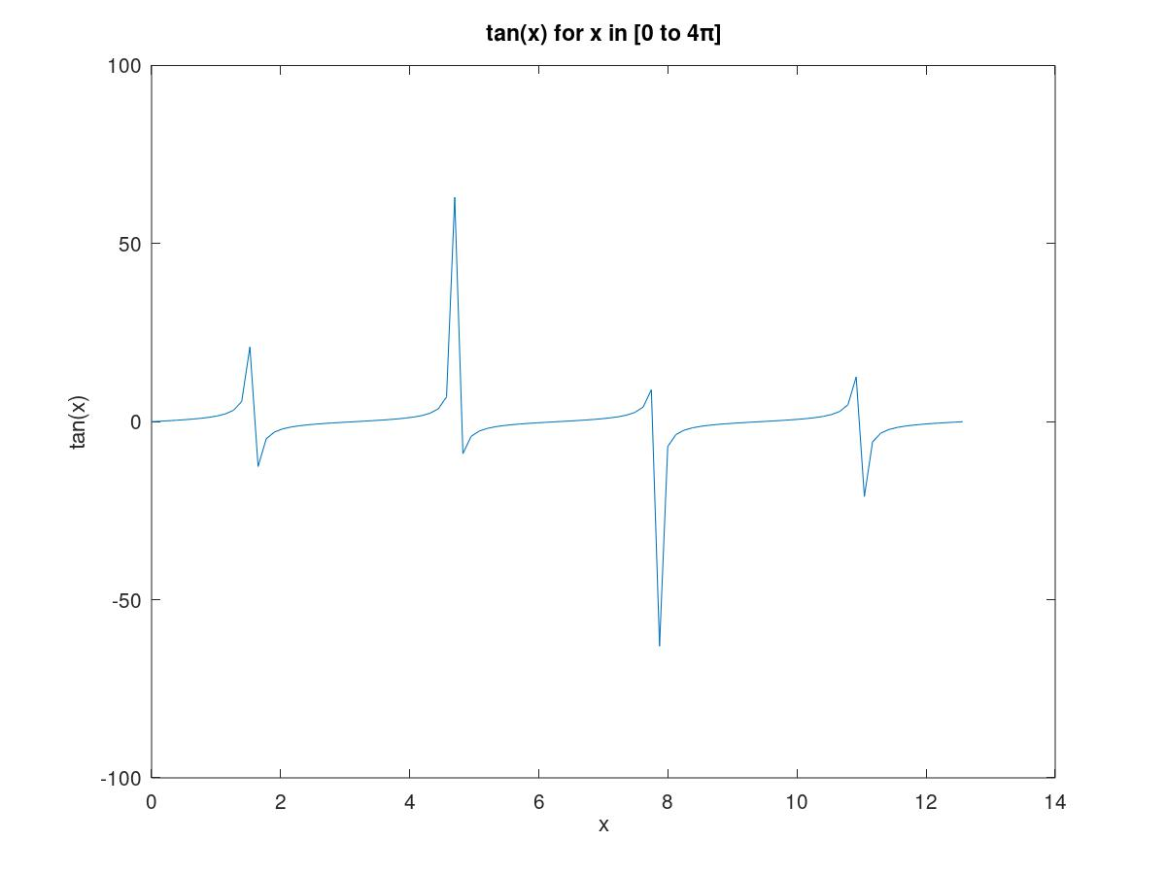

% (iii) tanx

plot(x,tan(x))

title ("tan(x) for x in [0 to 4π]");

xlabel ("x");

ylabel ("tan(x)");

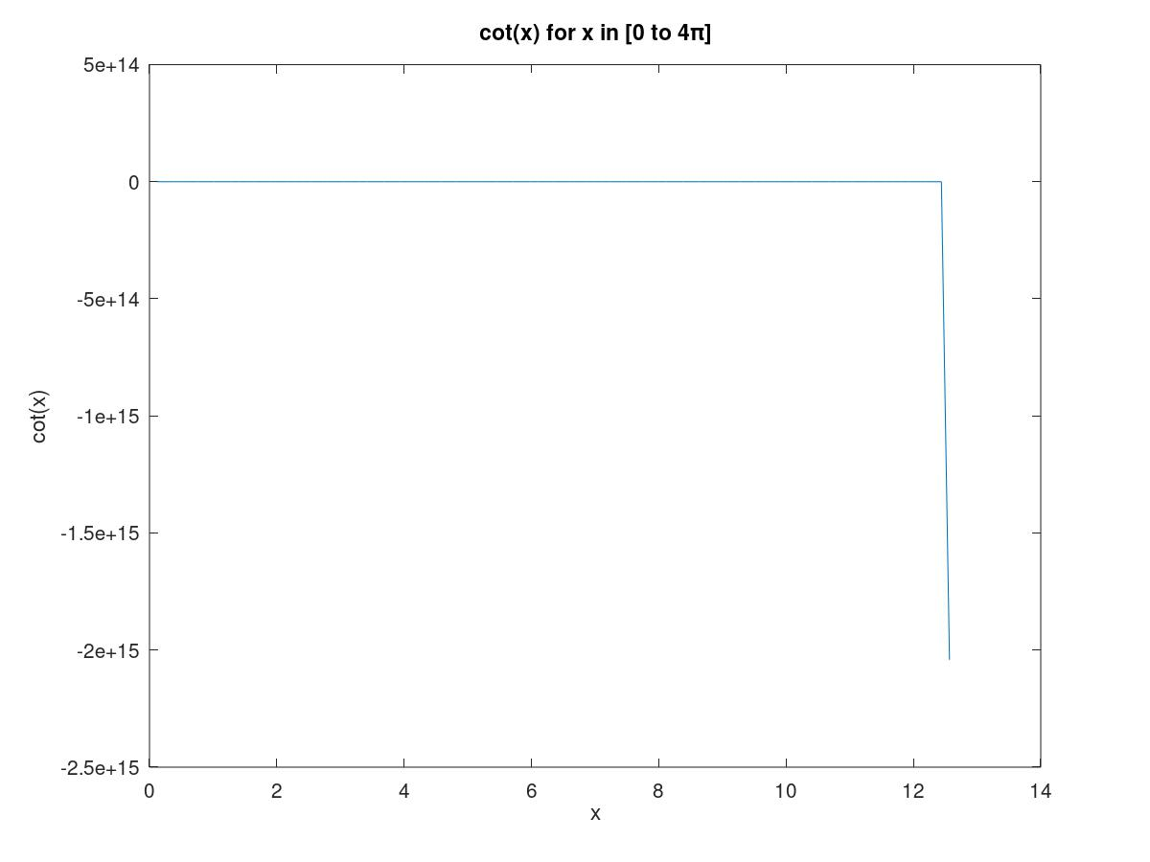

% (iv) cotx

plot(x,cot(x))

title ("cot(x) for x in [0 to 4π]");

xlabel ("x");

ylabel ("cot(x)");

% (v) e^x

plot(y,exp(y))

title ("e^x for x in [0 to 10]");

xlabel ("x");

ylabel ("exp(x)");

